**Response time, sec**

|  |  |  |  |  |  |  |  |  |  |  |  |  |  |  |  |  |  |  |  |  |  |
| --- | --- | --- | --- | --- | --- | --- | --- | --- | --- | --- | --- | --- | --- | --- | --- | --- | --- | --- | --- | --- | --- |
| Name | Users | 0 | 1 | 2 | 3 | 4 | 5 | 6 | 7 | 8 | 9 | 10 | 10 | 10 | 10 | 10 | 10 | 10 | 10 | 10 | 10 |
|  |  |  |  |  |  |  |  |  |  |  |  |  |  |  |  |  |  |  |  |  |  |
| Pollutant Releases | Avg | 0 | 0,97 | 1,25 | 1,22 | 1,28 | 1,28 | 1,31 | 1,14 | 1,83 | 1,58 | 1,59 | 2,2 | 1,75 | 1,65 | 1,88 | 2,74 | 1,94 | 1,54 | 1,97 | 1,79 |
|  | Avg90 | 0 | 1,08 | 1,61 | 1,56 | 2,02 | 1,94 | 2,07 | 1,98 | 2,46 | 2,87 | 2,77 | 3,51 | 2,92 | 2,85 | 2,81 | 5,42 | 4,43 | 3,07 | 4,68 | 4,82 |
|  | Max | 0 | 1,19 | 1,77 | 2,0 | 2,57 | 2,35 | 2,26 | 2,24 | 3,17 | 3,18 | 3,27 | 3,55 | 3,29 | 3,54 | 3,58 | 7,35 | 6,54 | 4,94 | 8,23 | 7,04 |
|  |  |  |  |  |  |  |  |  |  |  |  |  |  |  |  |  |  |  |  |  |  |
| Pollutant Transfers | Avg | 0 | 0,59 | 0,72 | 0,8 | 0,95 | 0,9 | 0,98 | 0,91 | 1,15 | 1,35 | 1,38 | 1,51 | 1,34 | 1,23 | 1,47 | 2,55 | 2,35 | 1,45 | 2,61 | 2,34 |
|  | Avg90 | 0 | 0,65 | 0,91 | 1,19 | 1,51 | 1,42 | 1,44 | 1,23 | 1,73 | 1,95 | 1,88 | 2,34 | 1,93 | 2,1 | 1,84 | 4,32 | 4,48 | 2,46 | 5,51 | 4,75 |
|  | Max | 0 | 0,72 | 1,09 | 1,73 | 2,36 | 1,95 | 2,03 | 1,67 | 2,27 | 2,47 | 2,49 | 2,48 | 2,61 | 3,3 | 2,34 | 4,99 | 5,41 | 4,45 | 9,36 | 6,39 |
|  |  |  |  |  |  |  |  |  |  |  |  |  |  |  |  |  |  |  |  |  |  |
| Waste Transfers | Avg | 0 | 0,91 | 1,0 | 1,14 | 1,09 | 0,99 | 1,09 | 1,2 | 1,27 | 1,36 | 1,38 | 1,58 | 1,49 | 1,43 | 1,52 | 2,54 | 2,08 | 1,59 | 2,9 | 2,57 |
|  | Avg90 | 0 | 1,03 | 1,3 | 1,57 | 1,35 | 1,44 | 1,48 | 1,6 | 1,85 | 1,84 | 1,9 | 2,11 | 1,85 | 1,92 | 1,9 | 4,01 | 3,46 | 2,54 | 4,82 | 3,88 |
|  | Max | 0 | 1,16 | 1,3 | 2,16 | 1,64 | 1,55 | 1,77 | 1,97 | 2,36 | 2,22 | 2,08 | 2,61 | 2,25 | 2,71 | 2,32 | 4,72 | 4,29 | 3,86 | 6,42 | 4,72 |
|  |  |  |  |  |  |  |  |  |  |  |  |  |  |  |  |  |  |  |  |  |  |
| Confidentiality | Avg | 0 | 0,83 | 0,93 | 0,98 | 0,97 | 0,88 | 0,86 | 1,02 | 1,19 | 1,26 | 1,3 | 1,43 | 1,26 | 1,19 | 1,36 | 1,78 | 1,48 | 1,36 | 1,66 | 1,8 |
|  | Avg90 | 0 | 1,06 | 1,14 | 1,22 | 1,41 | 1,08 | 1,45 | 1,39 | 1,66 | 1,74 | 1,79 | 2,12 | 1,91 | 1,65 | 1,83 | 3,04 | 2,41 | 2,0 | 2,73 | 3,32 |
|  | Max | 0 | 1,3 | 1,31 | 1,42 | 1,77 | 1,2 | 2,04 | 1,78 | 1,97 | 2,23 | 2,28 | 2,64 | 2,95 | 2,04 | 2,46 | 3,88 | 3,55 | 3,1 | 4,3 | 4,19 |

**Pollutant Releases**

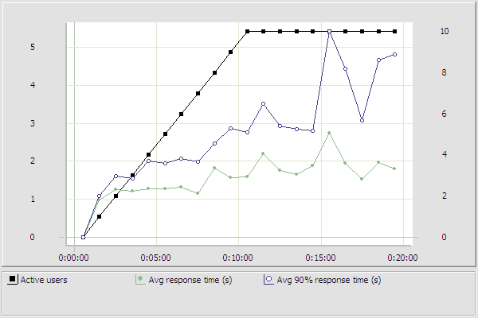

**Pollutant Transfers**

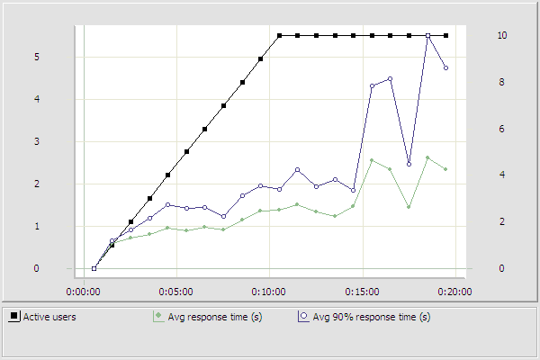

**Waste Transfers**

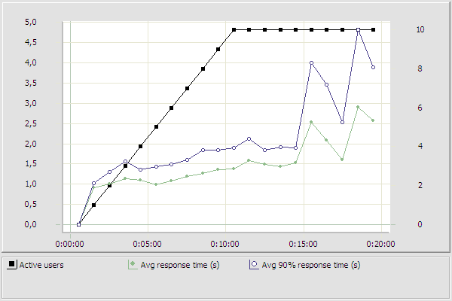

**Confidentiality**

